**Batch: B-1              Roll No.: 16010122104**

**Experiment No. 9**

**Grade: AA / AB / BB / BC / CC / CD /DD**

**Signature of the Staff In-charge with date**

|  |
| --- |
| **Title: Implementation of N-Queen Problem using Backtracking Algorithm** |

**Objective:** To learn the Backtracking strategy of problem solving for 8-Queens problem

**CO to be achieved:**

|  |  |
| --- | --- |
| Sr. No | Objective |
| CO 1 | Compare and demonstrate the efficiency of algorithms using asymptotic complexity notations. |
| CO 2 | Analyze and solve problems for divide and conquer strategy, greedy method, dynamic programming approach and backtracking and branch & bound policies. |

**Books/ Journals/ Websites referred:**

1. **Ellis horowitz, Sarataj Sahni, S.Rajsekaran,” Fundamentals of computer algorithm”, University Press**
2. **T.H.Cormen ,C.E.Leiserson,R.L.Rivest and C.Stein,” Introduction to algortihtms”,2nd Edition ,MIT press/McGraw Hill,2001**
3. **http://www.math.utah.edu/~alfeld/queens/queens.html**
4. [**http://www-isl.ece.arizona.edu/ece175/assignments275/assignment4a/Solving%208%20queen%20problem.pdf**](http://www-isl.ece.arizona.edu/ece175/assignments275/assignment4a/Solving%208%20queen%20problem.pdf)
5. [**http://www.slideshare.net/Tech_MX/8-queens-problem-using-back-tracking**](http://www.slideshare.net/Tech_MX/8-queens-problem-using-back-tracking)
6. [**http://www.mathcs.emory.edu/~cheung/Courses/170.2010/Syllabus/Backtracking/8queens.html**](http://www.mathcs.emory.edu/~cheung/Courses/170.2010/Syllabus/Backtracking/8queens.html)
7. [**http://www.geeksforgeeks.org/backtracking-set-3-n-queen-problem/**](http://www.geeksforgeeks.org/backtracking-set-3-n-queen-problem/)
8. [**http://www.hbmeyer.de/backtrack/achtdamen/eight.htm**](http://www.hbmeyer.de/backtrack/achtdamen/eight.htm)

**Pre Lab/ Prior Concepts:**

Data structures, Concepts of algorithm analysis

**Historical Profile:**

The **N-Queens puzzle** is the problem of placing N queens on an N×N chessboard so that no two queens attack each other. Thus, a solution requires that no two queens share the same row, column, or diagonal.

**New Concepts to be learned:**

Application of algorithmic design strategy to any problem, Backtracking method of problem-solving Vs other methods of problem solving, 8- Queens problem and its applications.

**Algorithm N Queens Problem: -**

void NQueens(int k, int n)

// Using backtracking, this procedure prints all possible placements of n queens on an n X n chessboard so that they are nonattacking.

{ for (int i=1; i<=n; i++)

         {

if (Place(k, i))

 {

x[k] = i;

if (k==n)

for (int j=1;j<=n;j++)   Print  x[j] ;

else NQueens(k+1, n);

    }

}

}

Boolean Place(int k, int i)

// Returns true if a queen can be placed in kth row and ith column.  Otherwise it returns false.

// x[] is a global array whose first (k-1) values have been set. abs(r) returns absolute value of r.

{

for (int j=1; j < k; j++)

if ((x[j] == i)  // Two in the same column

         || (abs(x[j]-i) == abs(j-k))) // or in the same diagonal

              return(false);

return(true);

 }

**Example 8-Queens Problem:**

The eight queens puzzle is the problem of placing eight chess queens on an 8×8 chessboard so that no two queens threaten each other i.e. no two queens share the same row, column, or diagonal.

**Solution Using Backtracking  Approach:**

The idea is to place queens one by one in different columns, starting from the leftmost column. When we place a queen in a column, we check for clashes with already placed queens. In the current column, if we find a row for which there is no clash, we mark this row and column as part of the solution. If we do not find such a row due to clashes then we backtrack and return false.

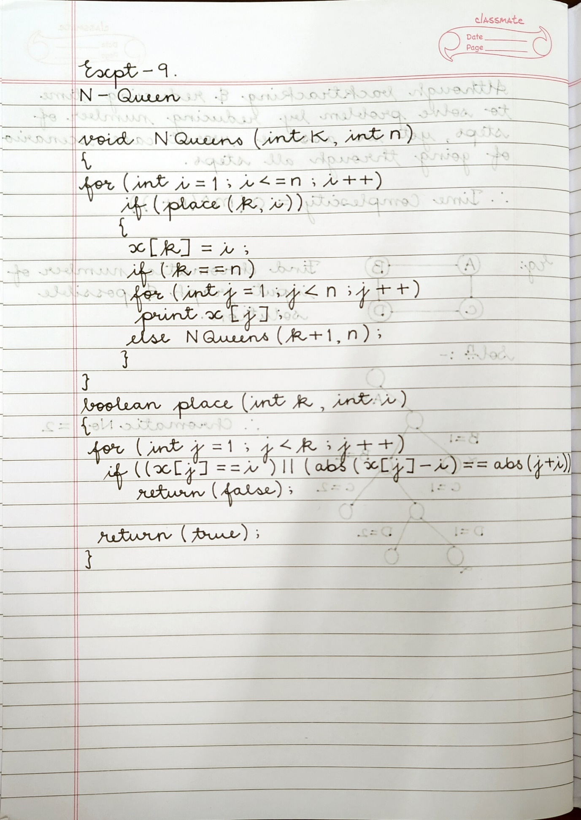**State Space tree for N-Queens (Solution):**

**Implementation (Code):**

def print_board(x):

"""

Prints the board layout based on the queen placements.

"""

n = len(x) - 1 # Size of the board

for row in range(1, n + 1):

line = ""

for col in range(1, n + 1):

if x[row] == col:

line += "Q " # Place 'Q' for the queen

else:

line += ". " # Place '.' for an empty square

print(line)

print() # Print a blank line after each board layout

def n_queens(k, n, x):

"""

Using backtracking, this function prints all possible placements of n

queens

on an n x n chessboard so that they are nonattacking.

"""

for i in range(1, n + 1):

if place(k, i, x):

x[k] = i

if k == n:

print_board(x) # Print the solution board layout

else:

n_queens(k + 1, n, x)

x[k] = 0 # Backtrack

def place(k, i, x):

"""

Returns True if a queen can be placed in the kth row and ith column

without attacking any other queen.

Otherwise, returns False.

"""

for j in range(1, k):

if x[j] == i or abs(x[j] - i) == abs(j - k):

return False

return True

if __name__ == "__main__":

n = int(input("Enter the number of queens (n): "))

x = [0] * (n + 1) # x[k] represents the column index of the queen in the

kth row

print(f"Possible placements of {n} queens on an {n}x{n} chessboard:")

n_queens(1, n, x)

**OUTPUT:**

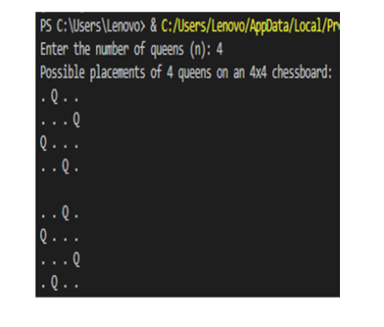

**Algorithm:**



**Analysis of Backtracking solution:**

